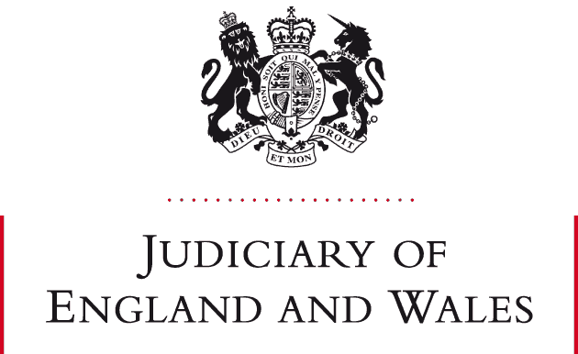

STATEMENT FROM RECORDER NICHOLAS ALLEN KC

- This statement is being issued with the approval of Mr Justice Peel, the FRC National Lead Judge.

- Pursuant to paragraphs 7 and 8 of guidance issued by the President of the Family Division on 24 February 2025 “Citation of Authorities: Judgments of Circuit Judges and District Judges”, I hereby retrospectively approve citation of the following judgments:

• CW v CH (MFPA 1984 Part III: Interim Applications) [2022] EWFC B1
• RA v KS (Interim Order for Sale) [2023] EWFC 102 (B)

RECORDER NICHOLAS ALLEN KC
24 April 2025

