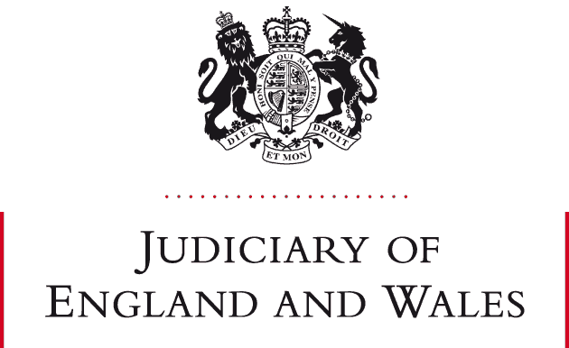

STATEMENT FROM DISTRICT JUDGE PATRICK TROY

:-
- This statement is being issued with the approval of Mr Justice Peel, the FRC National Lead Judge.

- Pursuant to paragraphs 7 and 8 of guidance issued by the President of the Family Division on 24 February 2025 “Citation of Authorities: Judgments of Circuit Judges and District Judges”, I hereby retrospectively approve citation of the following judgment:

- AS v RS 2024 EWFC 284 B as to the applicable costs regime in Part III M & FPA 1984

DJ Patrick Troy
Financial Remedies Court
Sitting at Leeds
24 April 2025

