In the Family Court Case No: [Case number]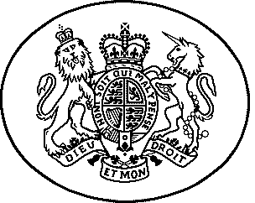
sitting at [Court name]

Order
The Forced Marriage (Civil Protection) Act 2007
The Family Law Act 1996
The Senior Courts Act 1981

 | The full name(s) of the children | Boy or Girl | Date(s) of Birth
 | [insert] | [insert] | [insert]
 | [insert] | [insert] | [insert]

Before [name of judge] in private on [date] without a hearing.

The parties: The applicant is [name]

The 1st respondent is [name], the [relationship to child]

The 2nd respondent is [name], the [relationship to child]

Recitals
- The judge read the following documents:
[Insert details]
(note these details should be included as an exception to the house rules)

- The judge heard the following oral evidence:
  - [Insert details]

- The declaration below is made in circumstances where relief by means of a decree of nullity is barred by virtue of sections 13(2) and (4) of the Matrimonial Causes Act 1973.

- The court was satisfied on the evidence that [name of person to be protected] did not validly consent to be married to [respondent name] at the ceremony of marriage held at [place] on [date].

IT IS DECLARED THAT:
- There is no marriage between [name of person to be protected] / [applicant name] and [respondent name] which is entitled to recognition as a valid marriage in England and Wales.

AND IT IS ORDERED THAT:
- [Insert provision re costs]

Dated [date]

