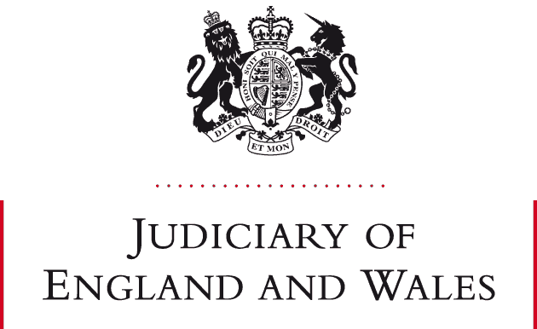

STATEMENT FROM DEPUTY DISTRICT JUDGE DAVID HODSON OBE KC(Hons)

- This statement is being issued with the approval of Mr Justice Peel, the FRC National Lead Judge.

- Pursuant to paragraphs 7 and 8 of guidance issued by the President of the Family Division on 24 February 2025 “Citation of Authorities: Judgments of Circuit Judges and District Judges”, I hereby retrospectively approve citation of the following judgment:
- AJC v PSP (2021) EWFC B25: when and why should long-term nominal periodical payments be converted into a substantive order

DDJ David Hodson
Central Family Court
17 April 2025

